**Manual Test Plan:**

**Prerequisites:**

This project requires:

* Python 3
* PyCharm
* MongoDB

Make sure you have all of those installed before beginning.

This project was developed with PyCharm Professional, but you can run the command line without it.

**Environment Setup and Configurations:**

git clone https://gitlab.engr.illinois.edu/yiyins2/sp21-cs242-assignment2.git

cd sp21-cs242-assignment2

Before running the test and command line, you need to create a ‘.env’ file that includes:

MONGODB_KEY = your mongodb URI

MONGODB_DB = your database name

You also need to create three collections inside your database:

* “subjects”
* “subject-courses”
* “courses”

For running the test cases:

Right click the “test” directory and hit “Run ‘Unittests in test’”

**Manual Tests:**

**Parse all subjects:**



Print invalid input for invalid year-semester.

Print the parsed list of all subject if valid year-semester.

The list of all subjects in database:

**Parse the list of all courses given subject:**

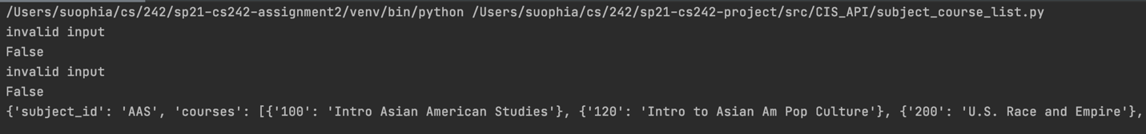

Print invalid input for invalid subject id and year-semester.

Print the parsed list of all subjects by subject for valid input.

The list of all courses partitioned by subject id in databased:

We can see that see that the number of subject documents and the number of subject courses documents are the same.

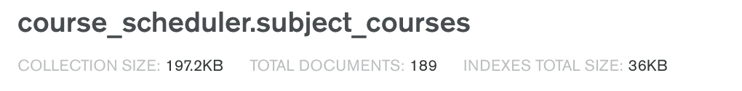 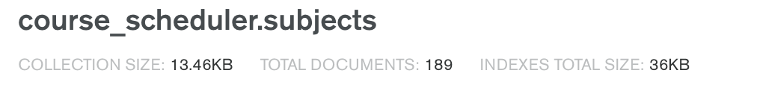

**Parse course info:**

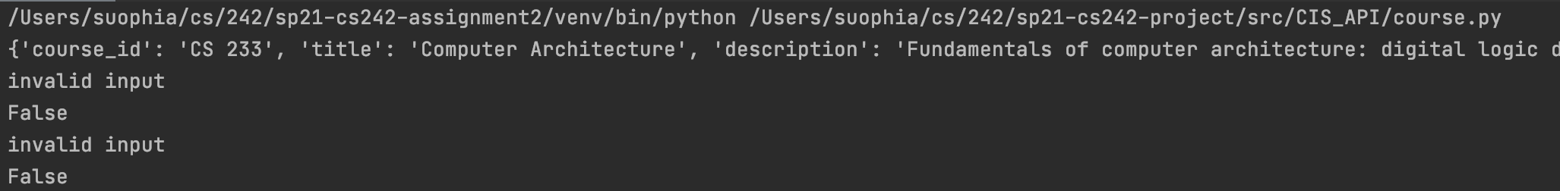

Print invalid input for invalid subject id and year-semester.

Print the parsed course info for valid input.

Course info in database:

